**Subject:** Food Processing & Preservation

**Topic:** Use of Low Temperature

**Submitted To:** Mr. Muhammad Bilal Hussain

**Submitted By:**

|  |  |
| --- | --- |
| Name | Roll No |
| **Khurram Shahzad** | **49128** |
|  |  |
|  |  |
|  |  |
|  |  |
|  |  |

**Session:** B (Evening)

**University Community College**

**Faisalabad**

**USE OF LOW TEMPERATURE**

T

he activities of food spoilage agents are very much dependent upon temperature. Enzymes require particular optimum temperature for their catalytic reactions; so do the microorganisms for their activities. Even the rate of pure chemical reactions is influenced by temperature, but these are not terminated as easily as enzyme- catalyzed reactions when temperature beyond the optimum range is encountered.

Temperature manipulation is a very useful tool for extending storage life of foods. When enzyme and microbial activities are undesirable in foods, temperature control may become necessary. Keeping food above the maximum temperature required for enzyme and microbial activity may mean encouraging chemical reactions as temperature is increased. Moreover, the nutritional quality of food is damaged if it is stored at a high temperature for a long time. The alternative procedure for checking the problems posed by enzymes and microorganisms is to hold food at temperature below the minimum for their activities. Low temperature also retards simple non-enzymatic chemical reactions in foods.

Normally enzyme activity and growth of food spoilage and pathogenic organisms best proceed at moderate temperature, i.e., in the mesophilic range Progressive' reduction in temperature below this initiates gradual decrease in the activity of food spoilage agents. Below a certain temperature, all life activities cease and so food is saved from deterioration and spoilage. The choice of temperature usually depends upon the objective of storage. If short-term storage is the aim, then the temperature could be decreased to near or slightly below the minimum required for the enzyme and microbial activities. In case food is to be stored for a long period, then the temperature has to be reduced far below the minimum at which any life activity can occur.

The terms cold storage and freezer storage, respectively, describe storage under the two situations. Cold storage refers to the storage condition where food is held at temperature above its freezing point. Freezer storage, on the other hand, describes the situation where food is held in frozen state at temperatures lower than the freezing point, which incidentally corresponds to temperature far below the minimum conducive for the activities of enzymes and microorganisms.

**5.1 EQUIPMENT**

The equipment required in low temperature storage installations is basically a refrigeration system whose power may be through non-mechanical or mechanical means. In the non-mechanical or natural system, ice or a suitable freezing mixture is employed. In mechanical refrigeration system, the liquid refrigerant that boils and vaporized at very low temperature circulates in a closed system. It absorbs heat from its environment and is transformed to the gaseous state. The gaseous refrigerant is reconverted into liquid state through a suitable mechanism that may involve either a vapour absorption cycle or a vapour compression cycle. In system using the vapour absorption cycle, the refrigerant moves from the liquid phase to the gaseous state: the gas is absorbed in a suitable fluid and the liquid refrigerant is refrigerated. This is employed in the manufacture of domestic refrigerators that work with gas, kerosene or other similar source of heat.

Refrigerators using the vapour compression cycle employ a device, the compressor to bring about the compression of the gaseous refrigerant. The electrical househoId refrigerators, freezers and common commercial equipment are of this type. In this simplest form, a vapour compression mechanical refrigeration system consist of four basic components-compressor, condenser, expansion valve and evaporator (Fig.5.1).

The compressor is the heart of the system and provides energy for is operation. It compresses the gas circulating in the hermetically sealed refrigeration system and passes it to the condenser. Here the gas is cooled and condensed to liquid form. The liquid refrigerant is passed to the evaporator at a high pressure through an expansion valve that results in changing the fluid refrigerant to an atomized vapour-liquid mixture at low pressure. In the evaporator the refrigerant obtains heat from the surrounding atmosphere and vaporizes. The gaseous vapours again pass through the compressor and the cycle is repeated.

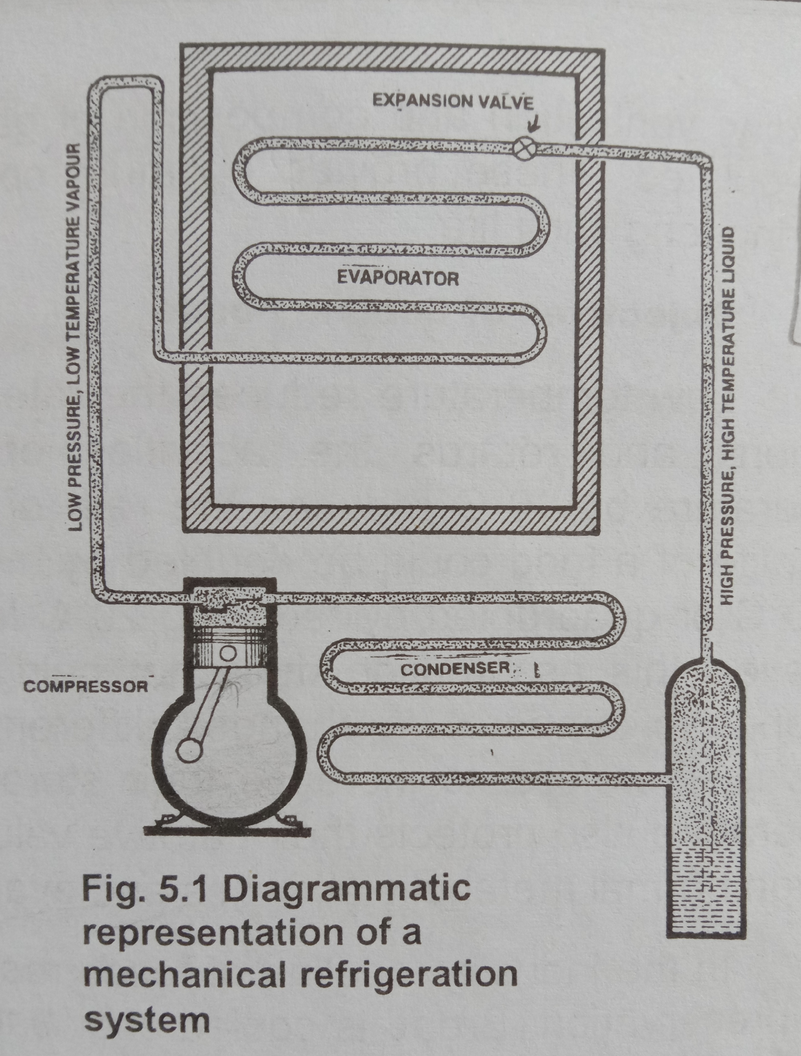

**5.2 REFRIGERATION SYSTEMS**

Refrigeration systems are generally classified into three groups based on the operating temperatures attainable:-

1. **High** **temperature systems** **-** used for air conditioning and cold storage equipment where temperatures between -3.9°C (25°F) to 7°C (45°F) or higher are needed.
2. **Medium temperature systems -** these are used for food storage and other applications requiring temperatures between -3.9°C (25°F) and -17.8°C (0°F).
3. **Low temperature systems** - employed where temperatures of -17.8°C (0°F) or lower are needed.

**5.3 USE OF ABOVE FREEZING TEMPERATURE**

The simplest form of equipment available for storage of foods at above freezing temperature is the domestic refrigerator and food displaying cabinets installed in supermarkets. In this equipment, temperature is lowered by the use of vapour compression mechanical refrigeration system. The shelf life of food commodities is short in these than when the same commodities are stored in commercial cold stores equipped with other sets of controls.

The commercial cold stores operating in Pakistan are large insulated rooms equipped with a mechanical cooling system that lowers the temperature of the chamber. The controlled atmosphere storage facilities (CA storage) are equipped with other mechanisms whereby humidity, ventilation and composition of gases inside the chamber may be regulated. These provide optimum conditions to the commodities, ensuring long shelf life.

**5.3.1 Objectives of Cooling Foods**

Low temperature reduces the rate of chemical and biochemical reactions and retards the activities of microorganisms. A fall in temperature by 10°C reduces the rate of these reactions by one-half. Thus, life of a food could be doubled by merely lowering its temperature by 10°C or quadrupled by reducing 20°C from the ambient temperature. However, this assumption does not hold good as each food material responds to temperature changes differently. A major object of cooling foods is, therefore, to increase their storage life. Holding foods at low temperature also protects their nutritive value and prevents moisture loss through normal metabolic activities and evaporation.

In the industry, cooling of foods may be done for purposes other than preservation. Bread is cooled after baking to facilitate slicing, while beef is cooled for ageing to improve its sensory characteristics. In the production of carbonated beverages, water is cooled before carbonation to increase the solubility of carbon dioxide. Wort is cooled in the brewing industry to precipitate some undesirable components and again after fermentation, the young beer is held at chilling temperature for impregnation of carbon dioxide and precipitation of other insoluble substances.

**5.3.2 Pre-treatment of Food for Low Temperature Storage**

Food raw materials get contaminated from different sources when they are gathered, harvested or slaughtered. Some contaminants such as microorganisms can be troublesome even under very ideal handling conditions. Food meant for cold storage is prepared according to the requirements for each particular commodity. Beef carcasses are washed, dewatered and then stacked in the chambers that are usually equipped with ultraviolet lamps. Eggs may be dipped in suitable mineral oil and then brought inside the cold store. Fruits are sorted for over-ripe or under-ripe ones, while vegetables are washed, drained and then stored.

Quite often the microbial load of fresh food destined for cold chemicals or storage is reduced by washing, heat treatment, use of chemicals or irradiation. Lemons, papaya or nectarines are immersed in hot water at a temperature of 46 to 54°C for one to four minutes to pasteurize. Some fruits and vegetables such as cucumbers and root crops are waxed to improve their appearance and keeping qualities. Shell eggs are usually dipped in light mineral oil 12 24 hours after lying _ the treatment retards dehydration as well as loss of carbon dioxide and maintains quality of the fresh eggs.

Chemicals are very frequently employed in the treatment of food materials prior to cold storage. Chlorine, acetates, ozone, sulphur dioxide and methyl bromide are commonly used to treat fruits and occasionally vegetables to prevent the growth of microorganisms. Ripening of plantains is retarded by application of purafil, prevent mangoes are treated with 2, 4, 5-trichlorophenoxy acetic acid for the same purpose. Sprouting in such commodities as onions, potatoes and carrots is prevented by the application of phenyl carbamates, maleic hydrazide or vapours of nonyl alcohol. Ethylene gas is often used as a color modifier to degree citrus fruits.

Irradiation has also been very helpful in cold storage of the many commodities. Quite often chilled meat is irradiated to destroy surface micro flora and parasites. Primarily, irradiation is used to sterilize the chambers that are now a day’s equipped with ultraviolet lamps, especially in rooms for storage of meat and cheese. Irradiation of the atmosphere also helps when higher relative humidity and increased storage temperatures are preferred.

**5.3.3 Cold Storage Procedure**

At home fresh commodities like onions, garlic, ginger, potatoes, sweet potatoes and others are stored in a cool corner of the house for quite some time. Meat, fish, eggs and other perishable commodities are kept in the refrigerator, if not utilized immediately. With storage at lower than ambient temperature, the shelf life of the food materials is considerably extended. Table 5.1 shows the useful storage life of some foods of plant and animal origin at different temperatures.

The refrigerator is general-purpose equipment in which only temperature is controlled and maintained at 4° to 10°C in the refrigerator cabinet. This temperature range is useful in prolonging the shelf life of several raw and prepared foods for a few days only. Fresh fruits and vegetables meant for storage in the refrigerator should be washed to remove the contaminants. It is a common notion among housewives that washed fruits and vegetables do not keep well when stored in the refrigerator. This is because these have not been dewatered. It is essential that extra water from their surface be removed before these are placed in the refrigerator.

|  |  |  |  |  |  |
| --- | --- | --- | --- | --- | --- |
| **Food** | | **Generalized average useful storage life, in days, at** | | | |
| **0°C (32°F)** | **22°C(72°F)** | **38°C(100°)** | |
| **Animal flesh** | | 6­ – 10 | 1 | Less than 1 | |
| **Fish** | | 2 - 7 | 1 | Less than 1 | |
| **Poultry** | | 5 – 18 | 1 | Less than 1 | |
| **Dry meat and fish** | | 1000 and more | 350 and more | 100 and more | |
| **Fruits** | | 2 – 180 | 1 – 20 | 1 – 7 | |
| **Dry fruits** | | 1000 and more | 350 and more | 100 and more | |
| **Leafy vegetables** | | 3 – 20 | 1 – 7 | 1 – 3 | |
| **Root crops** | | 90 – 300 | 70 – 50 | 2 – 20 | |
| **Dry seeds** | 1000 and more | | 350 and more | | 100 and more |

**Table 5.1: Generalized average useful storage life of animal and plant foods at different temperatures.**

In practice, the food processor does not take any chances with his commodities. The food is stored under controlled conditions, which guarantee extension the shelf life. Large capacity cold storages are employed for preserving fresh food raw materials such as fruits, vegetables and tubers.

**5.3.4 Factors affecting cold storage of foods**

The physiological phenomenon in plant and animal tissues is required to be slowed down to prevent metabolic changes and increase the shelf life. All plant materials respire even after harvesting. The rate varies from one material to another. During storage of fruits and vegetables, oxygen is taken up and carbon dioxide and water are evolved. Respiration in plant materials also results in heat generation and loss in the quality of the product. Animal tissues undergo anaerobic respiration, converting glycogen into glucose and finally to lactic acid. The energy produced during this process eventually gets dissipated as heat, while the lactic acid causes a fall in the pH of meat from above 7.0 to as low as 5.1. All respiration in meat ceases after a post-mortem period of one to 36 hours due to non-replenishment of glycogen or glucose. The refrigeration requirements of plant and animal foods are dependent on several factors. These are temperature relative humidity, composition of storage atmosphere and ventilation.

5.3.4.1. Temperature

The choice of temperature for refrigeration storage of foods depends primarily on the nature of food, estimated desired period of storage, composition of the storage atmosphere and pre-treatment of the raw material. The metabolic activities in some plant materials are very high that result in the production of heat during storage. For example, one ton of beans, sweet corn, okra or green peas stored for 24 hours at 4.5°C, generate over 252 kilocalories (1,000 British Thermal Units, BTU) of heat. Under similar conditions, over 504 to 1260 kilocalories (2,000 to 5,000 BTU) of heat are generated when the same quantity of carrots or potatoes are store. Most fruits are slow in respiration and thus release less heat during storage. Grapefruits, lemons oranges, cabbages, onions and tomatoes yield below 504 kilocalories (2,000 BTU) of heat under the same conditions and time.

Since the rate of metabolic activities of each food varies, so does the storage-life expectancy under any specific situation. Depending upon other conditions, some animal tissues, firm, ripe fruits and vegetables may be stored at optimum parameters of chilling temperature and relative humidity for a period of less than two weeks. In an atmosphere containing normal amounts of oxygen and carbon dioxide, beef, mutton, poultry, fish, lemons, nectarines, cabbage, carrots, green peas and spinach may be kept at just above freezing temperature for maximum storage life. Oranges, pineapples and potatoes will best be stored at 2 to 7°C. Bananas, grapefruits, lemons, limes, mangoes, tomatoes, green beans cucumbers, and sweet potatoes are kept at a temperature between 7 to 13°C for maximum life. Green lemons, oranges, cabbage, carrots, potatoes, sweet potatoes and eggs may be stored for over three months at optimum conditions of temperature and relative humidity.

Good insulation is essential to have adequate and uniform temperature inside the chamber throughout the storage period. The insulating material should normally be non-toxic, strong and with low heat conducting properties. Another factor that affects the temperature of cold storage chambers is the temperature difference between refrigeration coils and the storage atmosphere-smaller temperature difference is preferable over a large one, since the latter promotes vapour condensation on cooling coils. Proper air circulation equipment maintains a uniform temperature in cold stores. The specifications of the equipment have to coincide with cooling requirements of the food material.

5.3.4.2 Relative humidity

Control over relative humidity in the storage chamber is vital for extended storage. Too high relative humidity, above the optimum level, encourages microbial growth. Moulds grow in a relative humidity of 85 to 90 percent, yeasts require 90 to 92% and bacterial growth occurs on the food surface at near saturation. Relative humidity below the optimum results in moisture loss, causing wilting in fruits and vegetables or damage to the appearance of animal tissues, thereby incurring economic losses. In many vegetables, a decrease of 3 to 6% moisture will result in a marked loss in quality.

The optimum relative humidity for a particular raw material depends upon the storage temperature. In case of meat, the recommended relative humidity at 0°C is 92%, at 2.2°C 88% and 75% at 4.4°C. Thus, whenever temperature for storage is specified for a particular material, the relative humidity has also to be stated.

5.3.4.3 Composition of the storage atmosphere

In cold storage chambers, an atmosphere containing higher percentage of carbon dioxide and lower oxygen content than are found in air, is maintained to suppress the normal physiological processes in plant materials. Carbon dioxide content of above 10% significantly retards microbial growth on the food surface. Similarly, reducing oxygen concentration from the normal 21% to 10% or lower decreases the rate of respiration. The problem in manipulating the gas atmosphere lies in the difficulty of control. The storage process known as Controlled Atmosphere Storage or 'CA storage' has technically solved this. In CA storage, machines including scrubbers control the amount of different gases in sealed and insulated storage atmosphere. Ozone may also be used where higher relative humidity is employed, since it helps in the control of microorganisms. Eggs, for example, keep as well in a relative humidity of 90% in the presence of 1.5 ppm of ozone as in 85% in its absence.

5.3.4.4 Ventilation

Ventilation in cold storage chambers is important to prevent the development of stale odors and flavors and remove them from the atmosphere. This is also helpful in maintaining a uniform temperature and relative humidity. In case adequate ventilation or air circulation is not provided, then food in local areas of high humidity may undergo microbial decomposition. This would also prevent maintenance of uniform product composition in the storage atmosphere.

**5.4 USE OF BELOW FREEZING TEMPERATURE**

The rate of chemical reactions, activities of enzymes and microorganisms are retarded at cold storage or above freezing temperature. However, at below the freezing point of water most spoilage agents are completely inactivated. Chemical reactions proceed at a very slow rate. The human pathogens do not thrive below 3.3°C while normal food spoilage organisms will not grow below -9.4°C. Some enzymes retain their activity at even -77°C, although the rate of enzyme activity is considerably reduced. In freezer storage, length of storage and holding temperature are critical in determining the life of frozen foods. Since enzymes are inactivated by blanching or chemical treatment before freezing and most food spoilage organisms will not grow below -9.4°C, therefore, temperatures somewhere below this limit are normally selected for frozen food storage. This provides enough safeguards against any possible temperature rise. Considering the factors involved in food freezing including enzymatic and non-enzymatic reactions, microbiological changes and the cost of freezing and freezer storage, it has been found that freezing of foods to an internal temperature of -18°C and storage at this or lower temperature would be optimal for the maximum life of most products. However, use of temperature as low as -30°C for storage is not uncommon in commerce.

**5.4.1 Methods of Food Freezing**

Basically there are four methods by which foods are frozen commercially. These are: -

1. **Freezing in air -** Still air sharp freezing, blast freezing, and fluidized bed freezing.
2. **Indirect contact freezing -** Single plate freezer, double plate freezer, pressure plate freezer, and slush freezer.
3. **Immersion freezing -** Heat exchange fluid, compressed gas, and refrigerant spray.
4. **Cryogenic freezing**.

5.4.1.1 Freezing in air

This is the oldest and the cheapest method. A domestic freezer is a typical example. The food to be frozen should be prepared (washed, peeled, inedible portions removed, cut) and packed in small consumer packs. Meat, poultry and vegetables are often frozen at home. Meat and poultry are cut into small pieces, washed, drained and packed in polythene bags. Vegetables are normally blanched, cooled, drained and then packed. These packets should not be over 1 kg in weight. Efforts should be made to remove as much air as possible from the packages. These should spread in the freezer for quick freezing and not stacked one over the other. Once completely frozen, the packets may be stacked.

In the commercial freezers, food is placed in an insulated chamber on trolleys (Fig. 5.2) or conveyer belt (Fig. 5.3). It is frozen by passing cold air at a specific velocity and direction. The temperature used in still air sharp freezer ranges between -23°C and -29°C. In air blast freezers, it varies from -29 to -46°C. The air velocity in the still air freezing is negligible, while in the blast freezers it may be 15 meters per second. In case of fluidized bed freezing, cold air is passed through the food particles.

Except for the still air sharp freezers, all types using air as the freezing medium may be tailored for batch or continuous operations and are normally referred to as fast freezing methods.

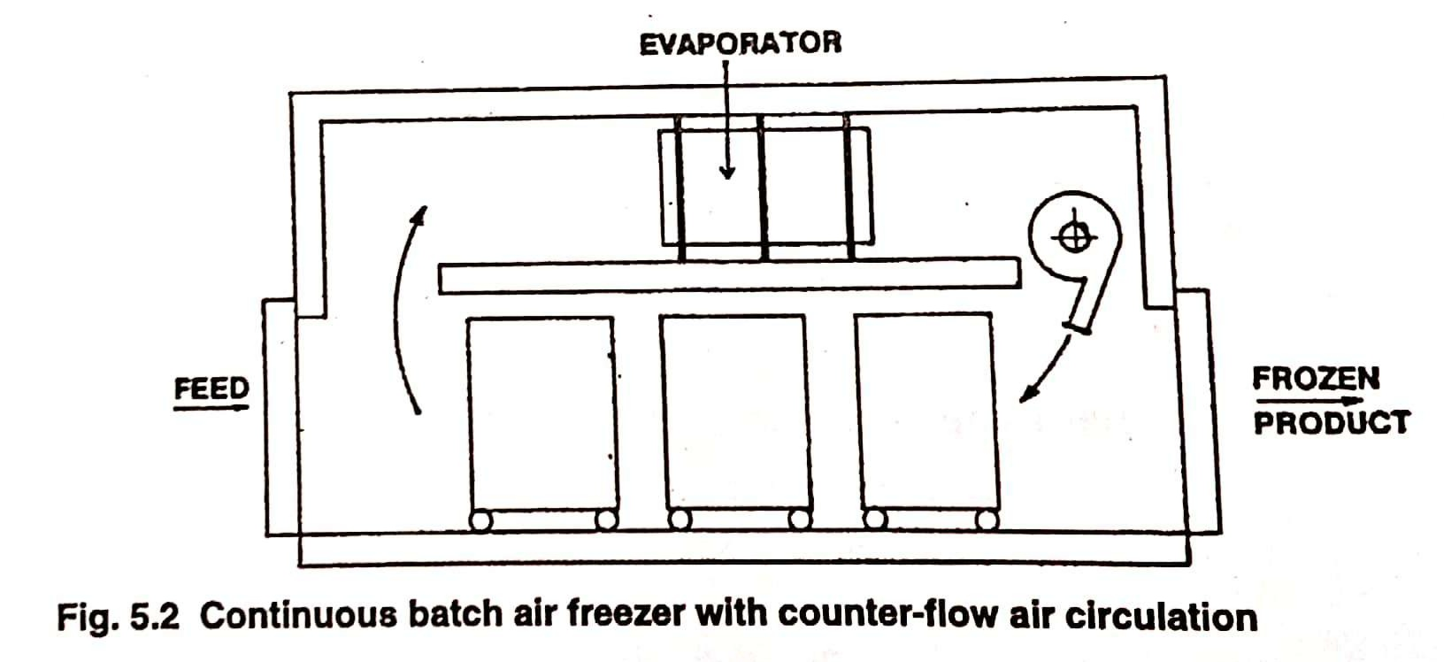5.4.1.2 Indirect contact freezing

In the indirect contact freezers, the freezing medium cools a surface (plates or walls) with which food comes in direct contact. As results of the heat exchange, it is frozen. Liquid foods and purees are pumped in-between the cold walls of a heat exchanger and frozen to the slush condition. The efficiency of indirect freezers depends upon the extent of contact between the cold surface (plates) and the food.

5.4.1.3 Immersion freezing

In this type, packaged or unpackaged food material is directly immersed in the freezing medium or the medium is sprayed on it. This method is very efficient since there is intimate contact between food or package and the freezing medium. This minimizes the resistance to heat transfer. However, since food items come directly in contact with the medium, only non-toxic substances, which would not impart undesirable odor, taste or color to the product, can be employed as freezing media. The common media used for the purpose include solutions of sugars, sodium chloride and glycerol. A sugar solution containing 62% sucrose or a brine containing 23% sodium chloride will be sufficient to lower the temperature to -21°C. Glycerol-water mixture can be used to obtain a much lower temperature, e.g., with 67 per cent glycerol solution in water, -47°C can be attained.

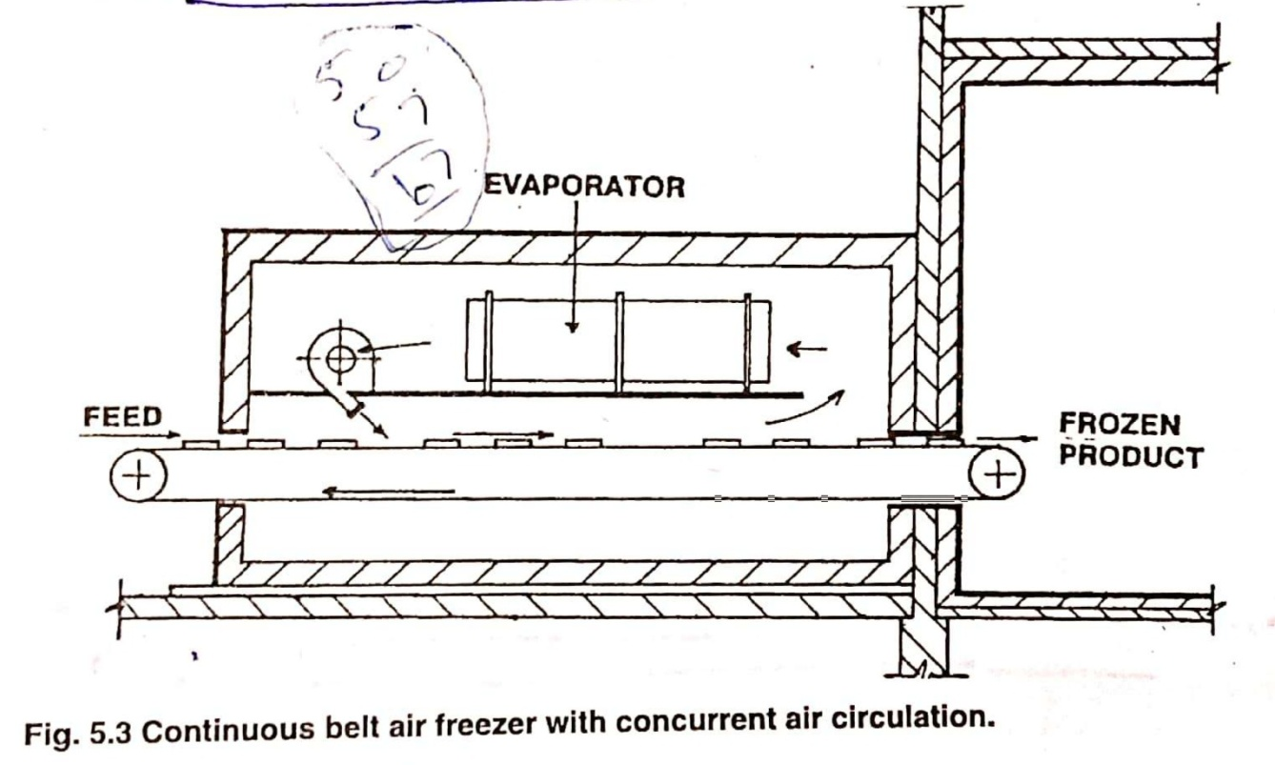5.4.1.4 Cryogenic freezing

This is similar to immersion freezing. Liquefied gases of extremely low boiling point are employed and the refrigerant itself serves as the freezing medium. Presently liquid carbon dioxide and liquid nitrogen that have boiling points of -79°C and -196°C respectively are used. The food commodity is immersed in or sprayed by the liquid gas and is frozen in a very short time (Fig. 5.4). Liquid nitrogen is preferred over liquid carbon dioxide because of its lower boiling point. The food is usually frozen to -46°C or above. In most fruits, vegetables, meat and fish, the freezing process may require from 1 to 3 minutes. Some fruits and vegetables, however, show physical quality defects when frozen with liquefied nitrogen gas. For cryogenic freezing, liquefied gases under pressure are more efficient than plain cold gas at the same temperature on account of the extra cooling capacity provided by the latent heat of vaporization. The method is more suitable for products of small size where freezing is completed in a very short time.

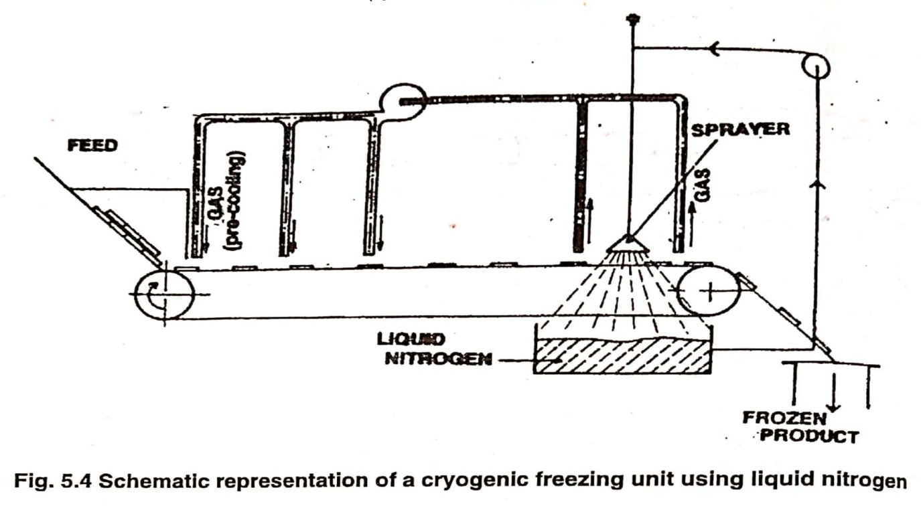**5.4.2 Effect of Freezing on Foods**

When foods are subject to below freezing temperatures, the moisture freezes and turns into ice crystals. The size of crystals may be small (in quick freezing) or large (in slow freezing) depending upon the rate of freezing. Since water expands on freezing by almost 9%, the frozen foods also increase in volume. During storage of frozen foods, ice crystals can grow owing to fluctuations in temperature, thus resulting in physical damage to the food material due to the formation of larger ice crystals.

During freezing operation all moisture present in the foodstuff does not instantaneously change into ice. It first cools to a temperature below the freezing point (super cooling) and then starts crystallizing. As the temperature is lowered, more water is crystallized. The remaining moisture in the food with the soluble solids forms a concentrated solution with a much lower freezing point. A stage is reached when no more water from the solution can be frozen independent of the dissolved solutes and the solution may freeze en masse. Such a solution from which water cannot be crystallized is known as `eutectic mixture`. It is the last to freeze in a food material and first to thaw when freezing operation is reversed (Fig. 5.5). Freezing ties up most of the moisture in solid form as ice and whatever remains in the foodstuff becomes very concentrated with dissolved solids. Consequently, moisture is made unavailable to the microorganisms and with combined action of low temperature shelf life of the food is increased. The eutectic mixture, if still in the liquid state, may ooze out from the package during storage.

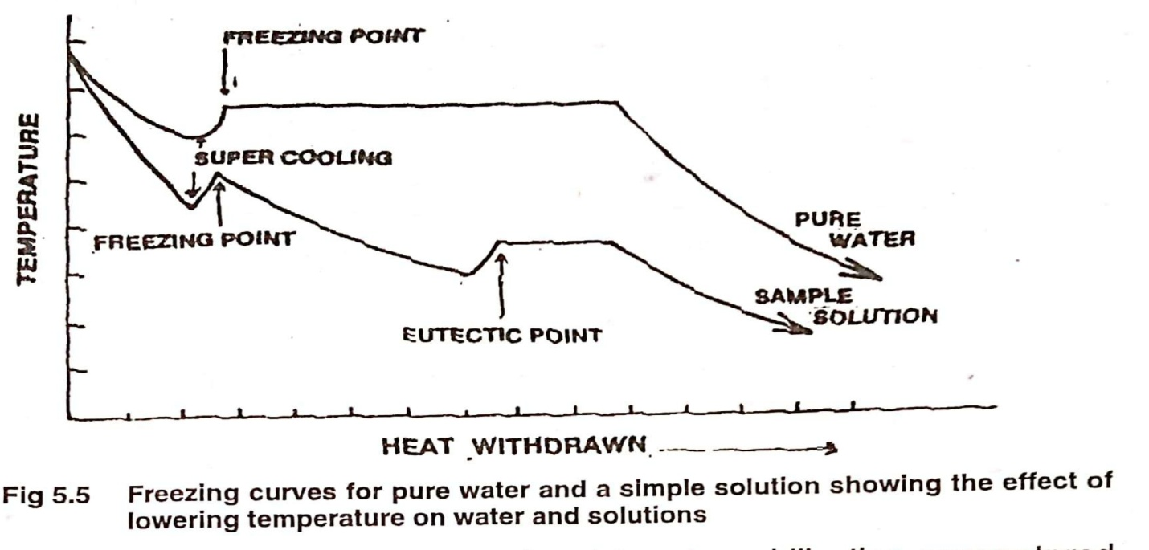

Very low temperature and moisture immobilization encountered in freezing retard or terminate chemical and enzymatic reactions. Normally the enzymes are inactivated before freezing by heat or chemical treatment. Hence, there are no active enzymes or enzyme activity is drastically subdued. Similarly, ordinary chemical reactions are very much slowed down. However, on prolonged storage, flesh foods such as meat, poultry and fish may become irreversibly dehydrated (freeze burn) as a result of chemical changes in animal proteins. When myoglobin is oxidized, the red pigment on the surface of meat is turned to brown metmyoglobin. Sometimes fats are either oxidized or hydrolyzed.

**5.4.3 Storage Life of Frozen Foods**

The period, for which a food commodity can be safely kept in a frozen state without appreciable loss in quality, depends upon its nature, its processing, and packaging as well as storage temperature. Though microbial activity ceases practically at -18°C, yet some enzymes still remain active at this temperature. Some chemical reactions also occur at temperatures far below freezing. Therefore, while subfreezing temperature may check the activities of microorganisms, enzyme-catalyzed reactions and other chemical changes still proceed but at a considerably slower pace. Each food commodity behaves differently during freezer storage; hence the period it can stay in such storage facilities will vary depending upon the factors enumerated above.

Heated canned orange juice can stay for up to 27 months at -18°C, while the same juice has a shelf-life of 10 months at -12°C and only 4 months at -6.7°C. Green beans and green peas can be kept for 11 to 12 months at -10°C and only 3 and 1 month at -12°C and -6.7°C, respectively. Raw chicken has a shelf life of 27 months at -18°C; 15.5 and less than 8 months at -12°C and -6.7°C respectively. Similarly, the life of all foods is much lower (almost half) at -6.7°C than at -12°C.

**5.4.4 Effect of Thawing on the Quality of Frozen Foods**

During freezer storage, intermittent fluctuation in temperature results in greater damage to food than either the freezing operation or storage. A fluctuation of 3°C in freezer storage temperature below -18°C can cause considerable damage to the food. During thawing, foods are subject to damage by physical, chemical, and microbiological means. When food thaws, ice crystals melt and change to liquid state; on refreezing these once again turn into ice crystals but larger in size and eventually cause physical damage to the product. The chemical reactions and enzyme activity would be faster at higher temperature.

As some microorganisms are not killed before and during freezing or subsequent frozen storage, these will become active when the food is thawed. Although microbiological changes in foods are negligible as a result of temperature fluctuations, yet this aspect cannot be ignored. It is only on rare occasions that commercial freezers breakdown without notice. Therefore complete thawing in operating freezers is uncommon.

Frozen foods (except ice cream and similar products) must be defrosted or thawed prior to consumption. The time required for thawing operation is very crucial to the quality of food material. The longer the food takes to thaw, the greater will be the damage caused by proliferation of microorganisms that have survived freezing and storage. For example, when frozen whole egg meat is thawed under a dielectric heat source, the time required is 15 minutes and negligible increase in microbial count occurs. The same product when thawed in running water at 21°C requires 12 hours, and the microbial population increases to about 300% of the original count. In case air at 21°C is employed for thawing, 36 hours are required and the microbial population increases by 750 per cent during this period.

**5.4.5 Effect of Freezing on Microorganisms**

Most microorganisms survive freezing temperature for quite some time. Since all moisture is not frozen at 0°C or slightly lower, some microorganisms may still find conditions suitable for their growth at as low as -5°C on meats, -10°C on ice cream, -11°C on fish and -12°C on peas. Yeasts have been reported to grow at -5°C on meat and -17°C on oysters, while moulds have been found growing at -7.8°C on meats and vegetables.

Subjecting food to below freezing temperature considerably reduces the microbial population, but does not sterilize it. Thus, while a canned food is expected to be sterile or near sterile, a frozen food is never near to that condition. It implies that more care has to be taken in handling a frozen than a heat processed or canned food. However, during freezing quite a substantial percentage of microbial population, between 50 to 80 per cent, is killed depending upon the following factors:

1. **Kind and state of microorganisms -** Generally bacterial are more resistant to destruction by freezing temperature than yeasts or moulds. Similarly, growth phase of the organism determines the effect of freezing temperature upon viability of the population—young and old cells are easily killed by freezing than mature ones. Vegetative cells in the lag phase are more susceptible than those in other phases of growth and the spores.
2. **Kind of food -** The composition of food invariably affects the susceptibility of microorganisms to freezing temperatures. While sugar, salt, proteins, colloids, fats and other food components may offer protection to microbial cells, high moisture content and low pH will hasten killing of microorganisms.
3. **Freezing and storage temperature -** Very low freezing or storage temperatures are not very lethal to microorganisms. The most critical range for microorganisms is between -1° to -5°C. Foods frozen or held for a long time at this range will have less number of viable cells. Slow freezing causes more damage to microorganisms but the same condition is also detrimental to product quality.
4. **Length of storage -** Longer storage periods are helpful in decreasing the numbers of viable microorganisms in a frozen food.